Project Design Phase-II
Data Flow Diagram & User Stories

Date | 07:03:2026
Team ID | SWTID-2026-3081
Project Name | LibSpace
Maximum Marks | 4 Marks

Data Flow Diagrams:

A Data Flow Diagram (DFD) is a traditional visual representation of the information flows within a system. A neat and clear DFD can depict the right amount of the system requirement graphically. It shows how data enters and leaves the system, what changes the information, and where data is stored.
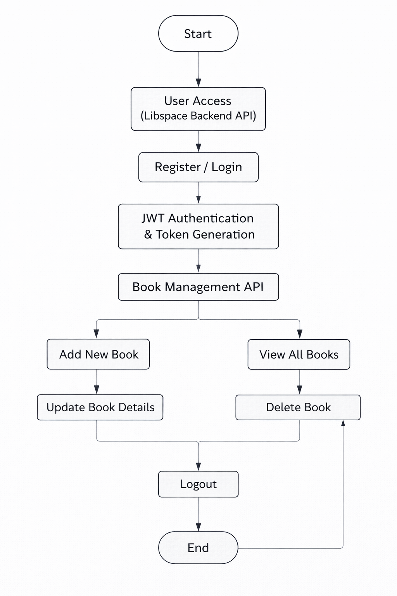

User Stories :

Use the below template to list all the user stories for the product.
User Type | User Story Number | User Story / Task | Acceptance criteria | Priority | Release
Customer  (Web user) | USN-1 | As a user, I can register with email and password to create an account. | User details are stored securely in database and password is encrypted using bcrypt. | High | Sprint-1
Customer  (Web user) | USN-2 | As a user, I can login using my registered credentials. | JWT token is generated on successful login and user can access protected routes. | High | Sprint-1
Customer  (Web user) | USN-3 | As a user, I can add a new book to my account. | Book details are saved in database and linked to the logged-in user. | Low | Sprint-2

Project Design Phase-II
Solution Requirements (Functional & Non-functional)

Date | 07:03:2026
Team ID | SWTID-2026-3081
Project Name | LibSpace
Maximum Marks | 4 Marks

Functional Requirements:
Following are the functional requirements of the proposed solution.
FR No. | Functional Requirement (Epic) | Sub Requirement (Story / Sub-Task)
FR-1 | User Authentication & Authorization | User Registration with email and password
 |  | Secure password hashing using bcrypt
 |  | User Login with credential validation
 |  | JWT Token generation on successful login
 |  | Protected routes using authentication middleware
 |  | Secure Logout functionality
FR-2 | Book Management (CRUD Operations) | Add new book record
 |  | View all books created by logged-in user
 |  | View single book by ID
 |  | Update book details
 |  | Delete book record
FR-3 | Database Management | Store user data securely in database

Non-functional Requirements:
Following are the non-functional requirements of the proposed solution.
FR No. | Non-Functional Requirement | Description
NFR-1 | Usability | The API should be well-structured, RESTful, and easy to integrate with any frontend application. API endpoints must follow consistent naming conventions and clear response formats (JSON).
NFR-2 | Security | All API requests must be secured using JWT authentication. Passwords must be encrypted using bcrypt. Unauthorized access to protected routes must be restricted.
NFR-3 | Reliability | The backend system should handle requests consistently without crashes. Proper error handling and meaningful HTTP status codes must be implemented to ensure stable performance.
NFR-4 | Performance | The API should respond to user requests within acceptable time (ideally under 2 seconds). Database queries should be optimized to ensure fast CRUD operations.
NFR-5 | Availability | The backend service should be accessible whenever required and capable of running continuously without unexpected downtime.
NFR-6 | Scalability | The system should be designed to handle increasing numbers of users and book records without performance degradation. The architecture should support future feature expansion.
NFR-7 | Maintainability | The codebase should follow clean architecture principles, modular structure, and proper documentation to ensure easy maintenance and future enhancements.
NFR-8 | Data Integrity | The system must ensure accurate storage and retrieval of user and book data, preventing duplication, corruption, or unauthorized modification.

Project Design Phase-II
Technology Stack (Architecture & Stack)

Date | 07:03:2026
Team ID | SWTID-2026-3081
Project Name | LibSpace
Maximum Marks | 4 Marks

Technical Architecture:
The Deliverable shall include the architectural diagram as below and the information as per the table1 & table 2
Table-1 : Components & Technologies:

S.No | Component | Description | Technology
1 | User Interface (Client Application) | Frontend application that interacts with Libspace backend APIs for authentication and book management | HTML, CSS, JavaScript / React.js (optional frontend)
2 | Application Logic – Authentication Module | Handles user registration, login, password hashing, and JWT token generation | Node.js, Express.js, bcrypt, JSON Web Token (JWT)
3 | Application Logic – Book Management Module | Implements CRUD operations for books and enforces user-specific access control | Node.js, Express.js (REST API)
4 | Database | Stores user information and book records securely | MongoDB / MySQL (based on your implementation)
5 | Middleware Layer | Protects routes and validates JWT tokens before allowing access to book APIs | Express Middleware
6 | API Testing Tool | Used to test and validate backend API endpoints | Postman
7 | Version Control | Source code management and collaboration | Git, GitHub

Table-2: Application Characteristics:

S.No | Characteristics | Description | Technology
1 | RESTful API Architecture | Backend follows REST principles with structured endpoints for authentication and book CRUD operations | Node.js, Express.js
2 | Secure Authentication Mechanism | Implements JWT-based authentication with encrypted passwords | bcrypt, JWT
3 | User-Specific Data Isolation | Ensures users can only access and manage their own book records | JWT verification & Database query filtering
4 | Scalable Backend Design | Designed to handle increasing users and book records without performance issues | Modular MVC Architecture
5 | Error Handling & Validation | Implements input validation and meaningful HTTP status codes | Express Validator / Custom Validation Middleware
6 | Database Relationship Management | Maintains structured relationship between Users and Books | MongoDB Schema / Relational DB with Foreign Keys
7 | API Security | Protects endpoints from unauthorized access and ensures secure data transmission | HTTPS, JWT, Environment Variables

